HURST PARK ESTATE RESIDENTS’ ASSOCIATION
AGM 2024
7.00pm on Sunday 23 June 2024
Milton Road Library

Attendance:
Present: members of the committee - Andrew Milbourn (chair), Nicky Webb (secretary), Sophie Musson, Yung-Chin Oei, Michael Page, Alun Reynolds, Robin Standing, Barbara Thomas, Tony Willoughby plus about 50 residents.

- Introduction and Welcome:
Andrew Milbourn welcomed residents to the meeting.

- Minutes of 2023 AGM
These were agreed as an accurate record of the meeting and will be uploaded to the HPERA website.

- Chairman’s Annual Report 2023-4
Andrew Milbourn presented his report to the meeting.

Committee
He began by introducing the members of the current committee. Barbara Thomas (Orchard Ave) is stepping down after 7 years on the committee, and Nicky Webb is resigning as secretary after 5 years but will remain on the committee as Highfield Avenue rep for another year. Andrew gave notice that there will need to be a new chair from next year.

Other volunteers would be very welcome, particularly if there is someone who is willing to take over producing the regular newsletter.

Michael Page proposed a vote of thanks to Nicky and Barbara which was passed unanimously.

Our activities in the year

Community Engagement
We’ve continued to put emphasis on organising events to help strengthen links between residents and to make the estate a nicer place to live. This year these included Carol Singing (December 2023) Advent Windows (December 2023 – Jan 2024).

Barbara Thomas has organised a group of volunteer gardeners who have continued to improve and maintain the community garden at the bottom of Hurst Park Avenue. Many thanks also to David Robinson and Rosie Lass who continue to maintain the small roundabout between Leys Road and Highworth Avenue.

Milton Road
Work continues on the scheme, which was one of the reasons HPERA was formed. Work started in 2022 and was originally supposed to be complete by now, but is now scheduled to finish by the end of the year. We have continued to engage with the project team, attempting to solve problems directly, which has been an often frustrating process.

On the plus side the roundabout is looking great now, and there are now cycle racks outside the shops on Milton Road. The end appears to be in sight!

Highworth Ave/Leys Road
We have advocated for an improved design when the cycle path and planters are reinstated between Highworth Ave and Leys Road and have received a draft design. We are still awaiting another one.

Planning Matters
The committee has spent a significant amount of time on the ongoing question of planning for 45 Highworth Ave. AM reminded the meeting that the original proposal in 2018 was for 6 houses, and this and other variations have all been rejected. The current proposal, which has been rejected but is now at appeal, included misleading information about the size of the houses proposed. It is thanks to Michael Page’s close attention to the detail that it was pointed out that these houses are significantly larger than the previous proposal (one house 25% larger, the other 33%). A decision on the appeal is imminent. HPERA fully accepts that the site will be developed, but we hope it will be more in keeping with the style of the estate – perhaps 2 semi-detached houses in line with the other houses on the street – rather than any ‘back garden’ development.

Residents’ parking scheme
This needs no introduction! As you all know, a majority of those who responded to the GCP consultation in late 2022 were in support of a scheme and so it will go ahead. We are disappointed that none of the modifications we – and many individual respondents – suggested have been taken on board, with the exception of the reinstatement of parking spaces on Arbury Road. We have struggled to get any information about the detail that is now proposed, and even errors such as maps showing parking spaces across driveways have not been addressed. There have been no meetings with officers and no real progress. The matter is now scheduled to go to the County Transport Committee meeting which is scheduled for July 2024, but there is still no confirmation.

Speedwatch
Orchard Avenue resident Riki MacDonald has organised a group of volunteers to monitor the speed of drivers in Orchard Avenue during peak times. Motorists found to be driving well excess of the 20mph speed limit are sent warning letters by the police. Hopefully the visibility of volunteers has some kind of deterrant effect on people driving too fast.

Environmental improvements
Thanks to our councillor Sam Carling, the old postal storage boxes in Mulberry Close and Highfield Ave have at last been removed.

Around 50 trees are missing from verges in the estate and a programme of new planting is underway.

The city council has undertaken to repair the other planter under the trees on Highworth Avenue.

Communications
The e-newsletter remains the main way we communicate with residents. Please do join via the website if you’re not already on the list.

The new website is maintained and a useful archive.

We have an active Facebook group which any member can use to raise or discuss issues.

At long last a noticeboard has been installed at the bottom of Hurst Park Avenue which we can use to publicise events and issues.

Cambridge Growth
Michael Gove proposed Cambridge should be 8th largest city in England – 150,000 extra houses are proposed. AM suggested we might all wish to ask candidates in the General Election whether they intend this level of growth to be maintained. How will Cambridge’s infrastructure cope with the increase especially as local children are currently having to go to school in St Neot’s. How will residents’ views be considered?

Northern design code – a council project to improve Arbury and King’s Hedges. We aren’t included because different style of housing.

Questions & Answers
There were some questions.

Repair of existing planter on Highworth Ave/Leys Road:
Attenders asked for more detail on this as it was felt there’s no point at all in repairing without doing something to prevent lorries damaging them again. Am undertook to find out more about what is proposed.

Steve Bunkall asked for clarification about the process for approval of the parking scheme. AM confirmed that the matter should go to the County Transport sub-committee in July, but that some sort of scheme will go ahead as a majority were in favour.

Alun Reynolds proposed a vote of thanks AM’s hard work.

- Treasurer’s report

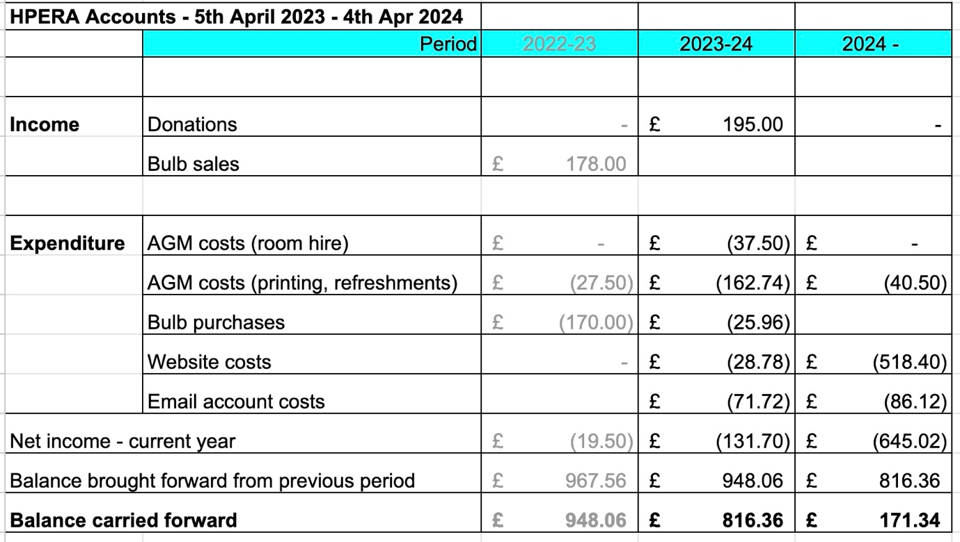

Tony Willoughby (treasurer) presented the accounts for the year to 4 April 2024, which showed expenses during the year. Although there has been little expenditure in the past year we have had to renew our website hosting and email addresses for the next 3 years recently so our funds are now rather depleted. There is the possibility of looking for a new (cheaper) host, or not having a website but attenders at the meeting felt that it was important to have a website available to all rather than relying on, say, the Facebook group alone.

Tony requested that donations be made to replenish the account.

- Election of committee and officers

Fran Malarée (Leys Avenue) has indicated her willingness to serve as secretary. She was formally nominated by Nicky Webb and seconded by Michael Page. The meeting voted unanimously that she be appointed.

The rest of the committee had indicated they were willing to continue. Alun Reynolds proposed, Naomi seconded. The meeting unanimously voted in favour of the rest of the committee being reappointed and so it now comprises:

Andrew Milbourn (Chair, Leys Ave), Fran Malarée (Secretary, Leys Ave), Tony Willoughby (Treasurer, Leys Ave), Michael Page (Hurst Park Avenue), Yung-Chin Oei (Mulberry Close), Alun Reynolds (Orchard Avenue), Nicky Webb (Highworth Avenue), Sophie Musson (Highworth Avenue).

- Any Other Business

Andrew asked residents to raise any concerns direct and put forward any ideas about future activities. There being no further business, the meeting concluded at 8.00pm, after which Anna Pamphilon, Passivhaus architect and Highfield Avenue residents, gave an illuminating presentation about how householders might improve the thermal efficiency of their homes and the biodiversity of their gardens. Afterwards residents were invited to share a dessert and talk to neighbours.

